float y, z, temp;

void setup()
{
pinMode(5, OUTPUT);
pinMode(6, OUTPUT);

pinMode(A4, INPUT);
pinMode(A5, INPUT);

Serial.begin(9600);
}

void loop()
{
y = analogRead(A5);
z = analogRead(A4);

temp = (z * 5.0 / 1023.0);
temp = (temp - 0.5) * 100;

Serial.println("--------------------");

Serial.print("Temperature: ");
Serial.print(temp);
Serial.println(" C");

Serial.print("Light Reading: ");
Serial.println(y);

if (temp > 30)
{
digitalWrite(6, HIGH);
Serial.println("MOTOR ON");
}
else
{
digitalWrite(6, LOW);
Serial.println("MOTOR OFF");
}

if (y < 550)
{
digitalWrite(5, HIGH);
Serial.println("BULB ON");
}
else
{
digitalWrite(5, LOW);
Serial.println("BULB OFF");
}

delay(1000);
}

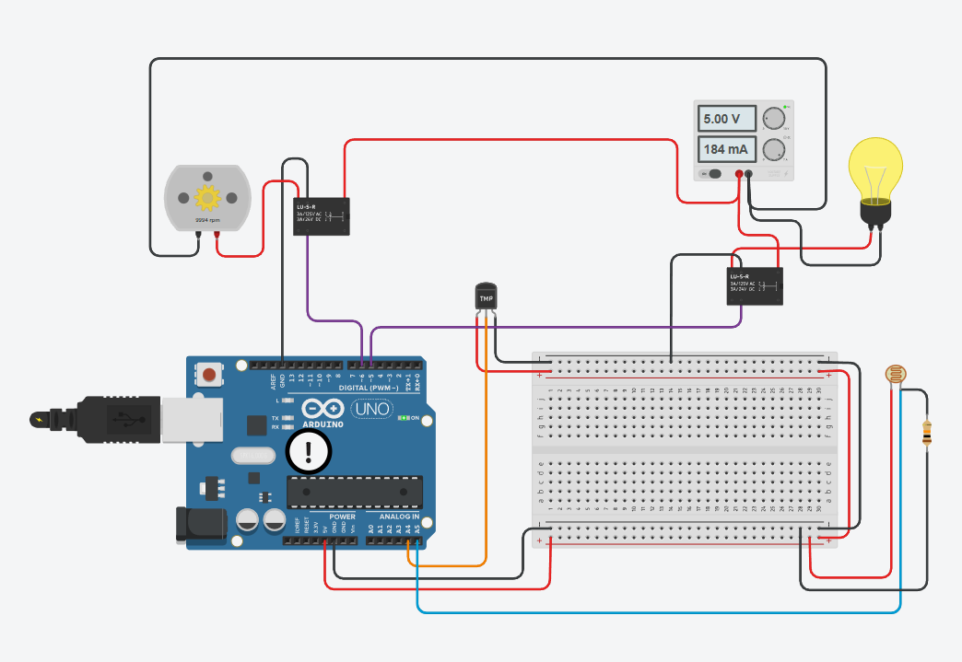

https://www.tinkercad.com/things/hjX2OUHw26s-smart-home-energy-management?sharecode=dvWMqfrBROa-sUnW7YKNPa7fjHNuTSwDb33y52y1kyw

